CLOUD COMPUTING LAB

Name: Maria Abdul Malik
Reg No: 2023-BSE-076
Submitted to: Sir Muhammad Shoaib
Class: 5B

LAB #11

Task 0 Lab Setup (Codespace & GH CLI)
- taskA_codespace_create_and_list.png
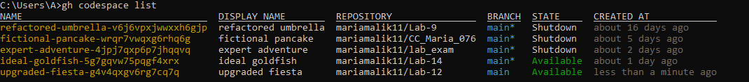
- taskA_codespace_ssh_connected.png
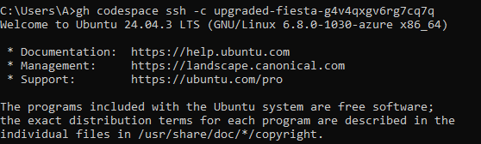

Task 1 — Provider & Basic variable (variable precedence)
- task1_touch_main_tf.png
- task1_main_tf_provider.png
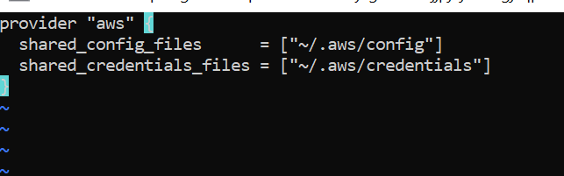
- task1_terraform_init.png
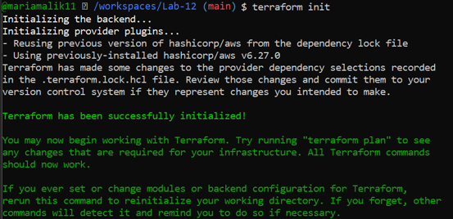
- task1_variable_and_output_added.png
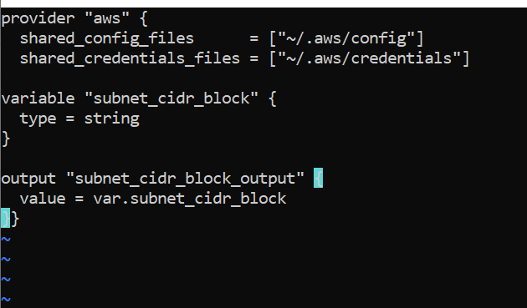
- task1_apply_prompt_for_var.png
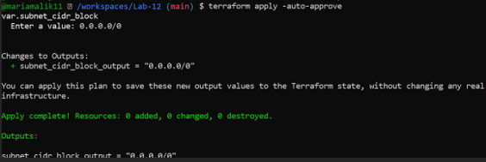
- task1_apply_with_default.png
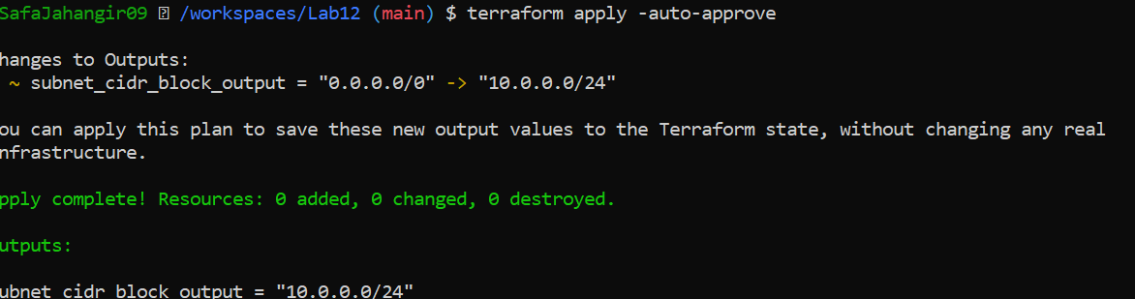
- task1_env_var_set_and_apply.png
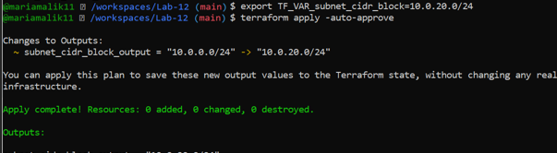
- task1_terraform_tfvars_and_apply.png
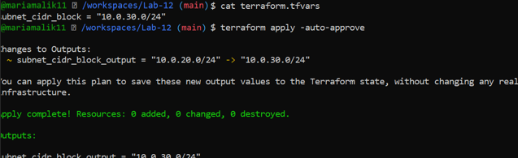
- task1_var_override_with_dash_var.png
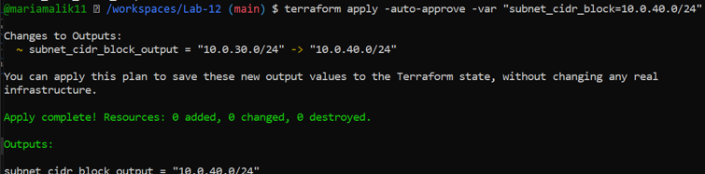
- task1_printenv_tf_var_and_unset.png
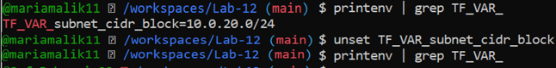

Task 2 — Variable validation & sensitive / ephemeral variables
- task2_subnet_variable_with_validation.png
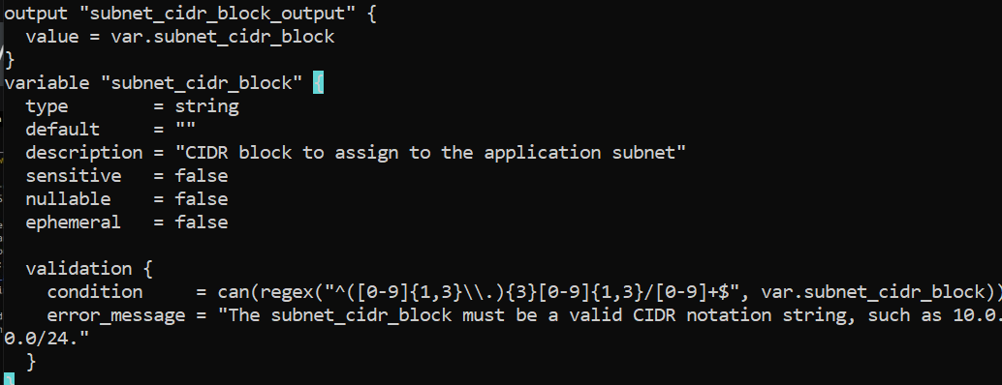
- task2_subnet_validation_error.png
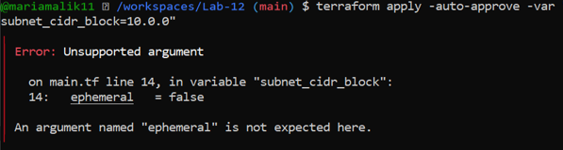
- task2_api_token_variable_added.png
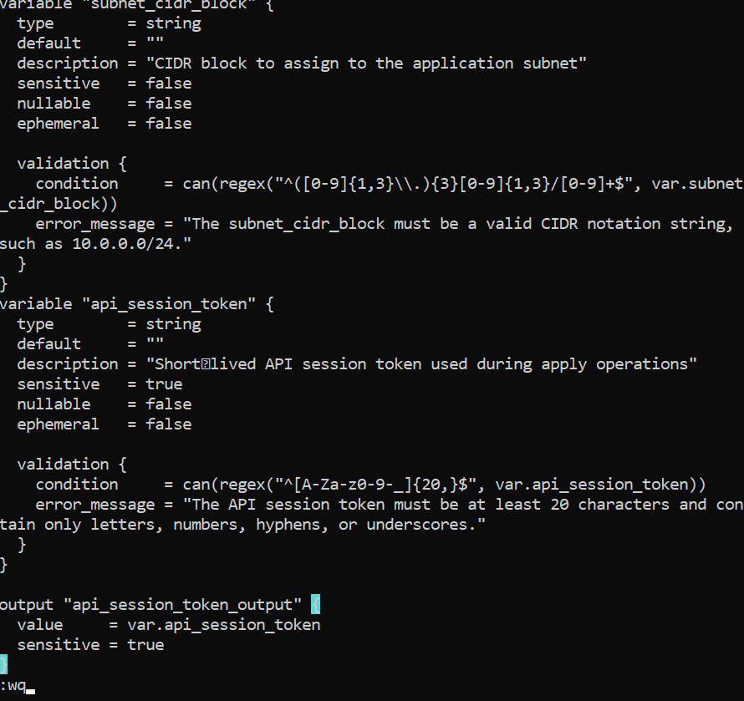
- task2_api_token_apply_sensitive.png
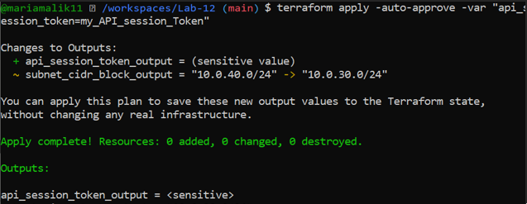
- task2_check_terraform_state_api_token.png
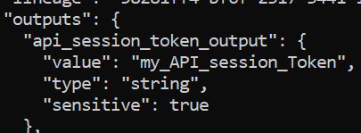
- task2_api_token_ephemeral_error.png
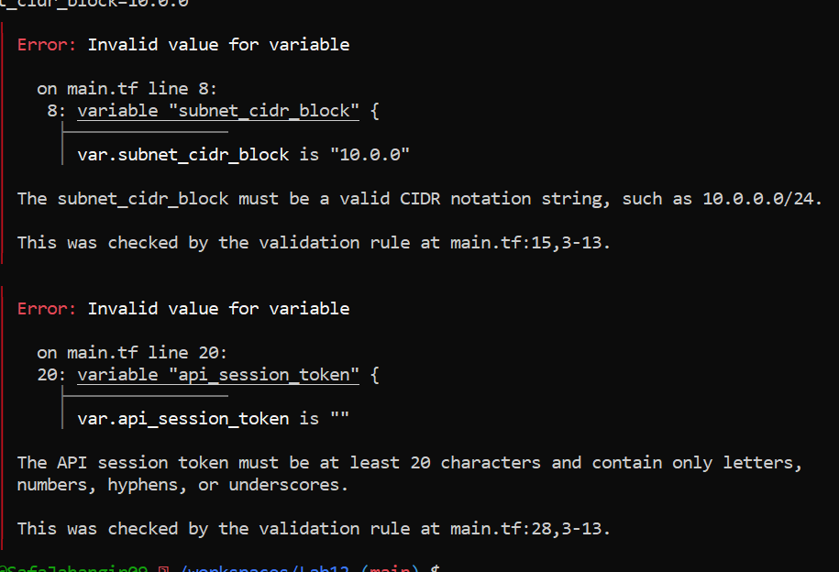
- task2_api_token_default_apply.png
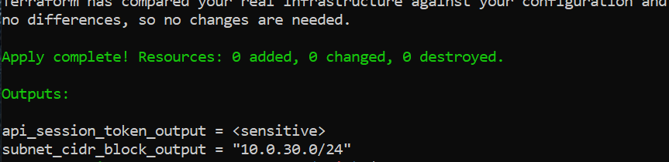

Task 3 — Project-level variables, locals, and outputs
- task3_variables_added.png
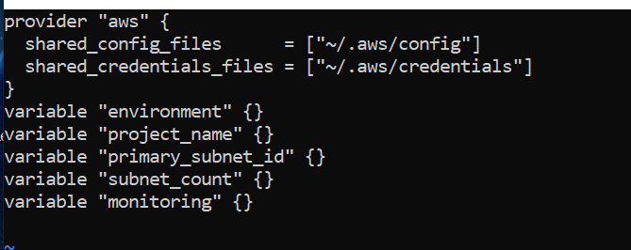
- task3_locals_tf_created.png
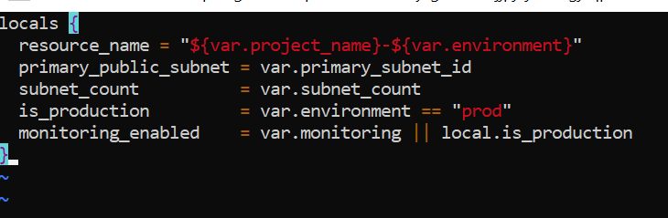
- task3_outputs_apply.png
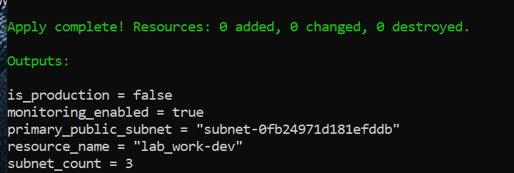

Task 4 — Maps and Objects
- task4_tags_variable_added.png
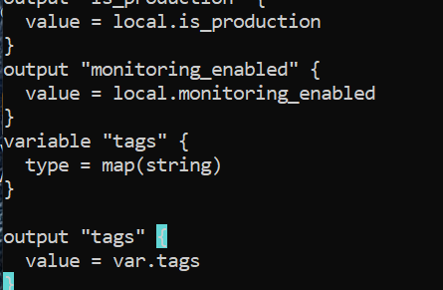
- task4_tags_output.png
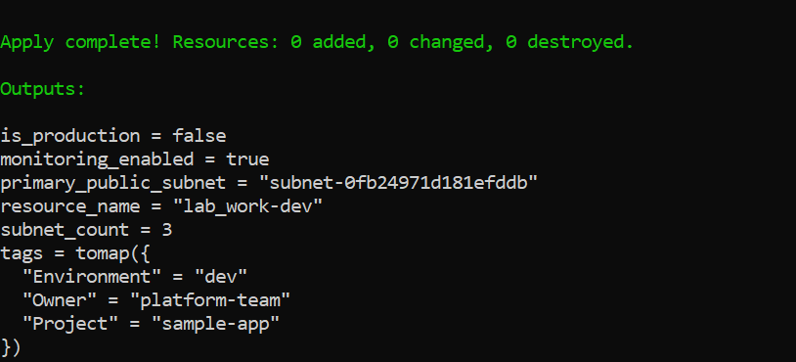
- task4_server_config_output.png
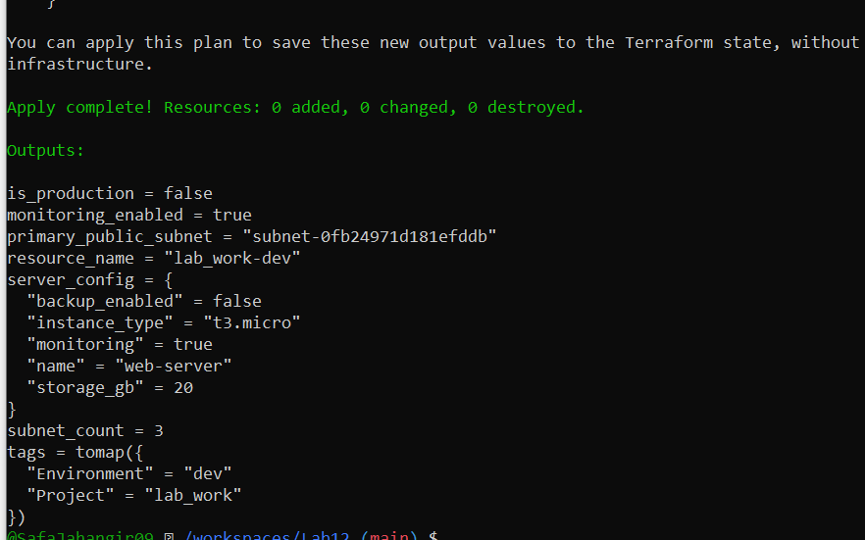

Task 5 — Collections: list, tuple, set & mutation via locals
- task5_collections_defined.png
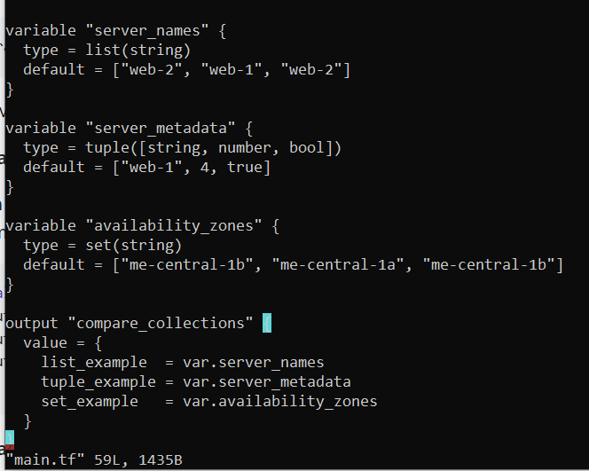
- task5_compare_collections.png
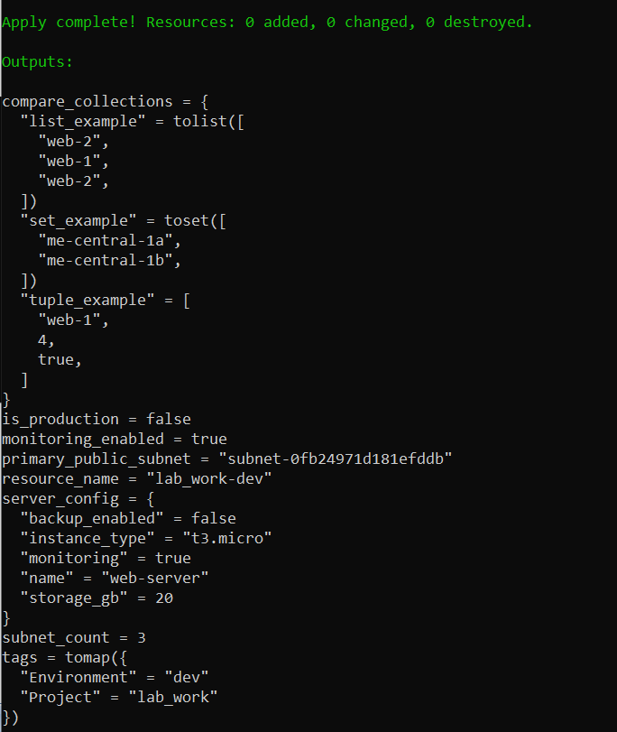
- task5_locals_mutations.png
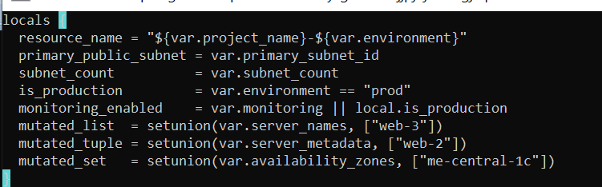
- task5_mutation_comparison.png
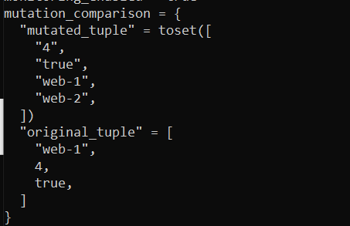

Task 6 — Null, any type & dynamic values
- task6_optional_tag_variable.png
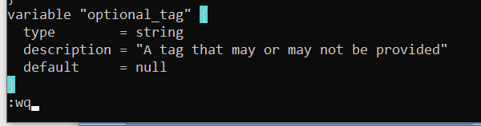
- task6_locals_merge.png
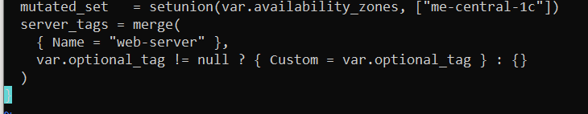
- task6_optional_tag_no_value.png
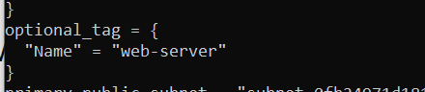
- task6_optional_tag_with_value.png
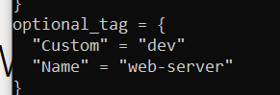
- task6_dynamic_value_string.png
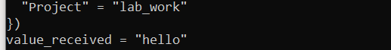
- task6_dynamic_value_number.png
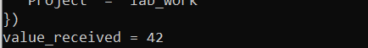
- task6_dynamic_value_list.png
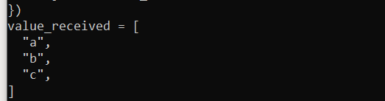
- task6_dynamic_value_map.png
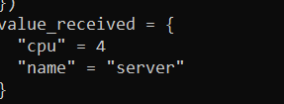
- task6_dynamic_value_null.png(previous outputs only)
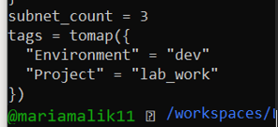

Task 7 — Git ignore
- task7_gitignore_created.png
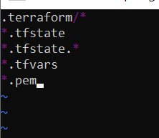

Task 8 — Clean-up then build real infra (VPC, Subnet, IGW, routing, default route table)
- task8_clean_files.png
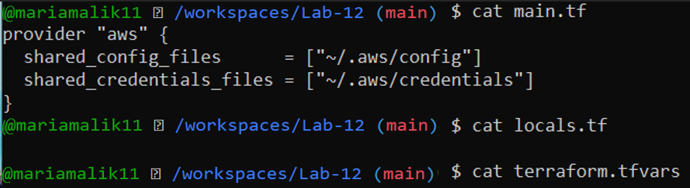
- task8_variables_recreated.png
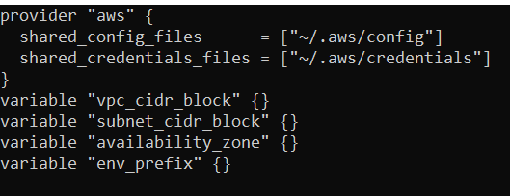
- task8_vpc_resources_added.png
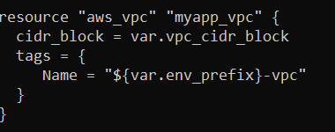
- task8_subnet_resources_added.png
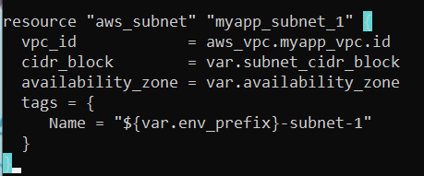
- task8_terraform_tfvars_vpc_values.png
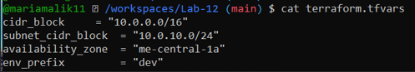
- task8_vpc_subnet_apply.png
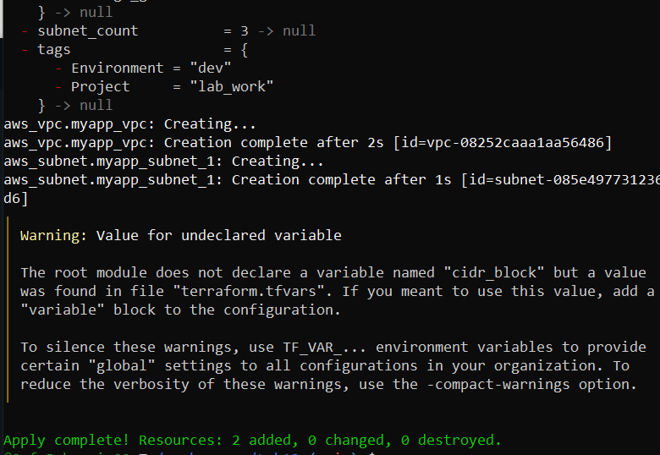
- task8_igw_route_table_before_apply.png
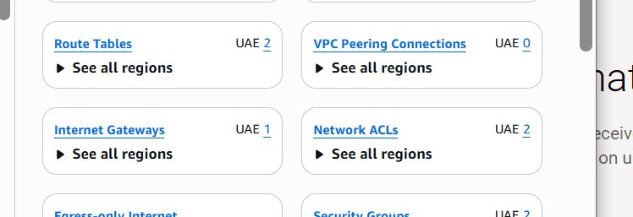
- task8_igw_route_table_after_apply.png
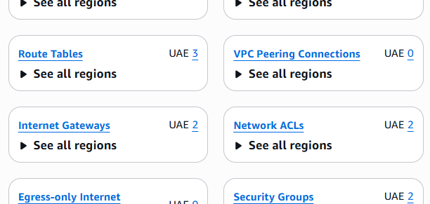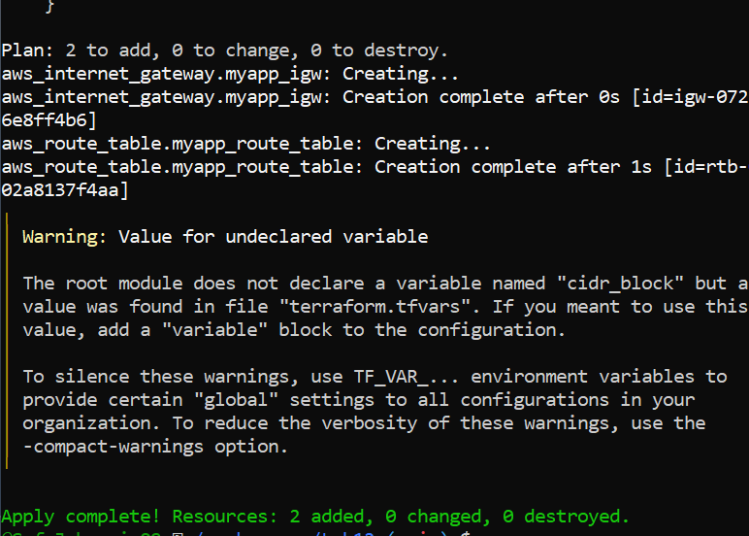
- task8_association_apply.png
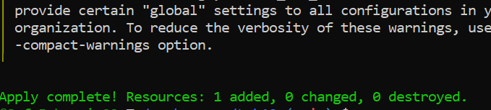
- task8_default_route_table.png
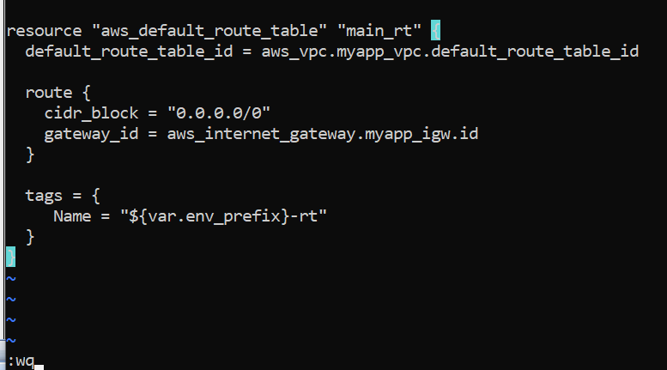
- task8_default_route_table_apply.png
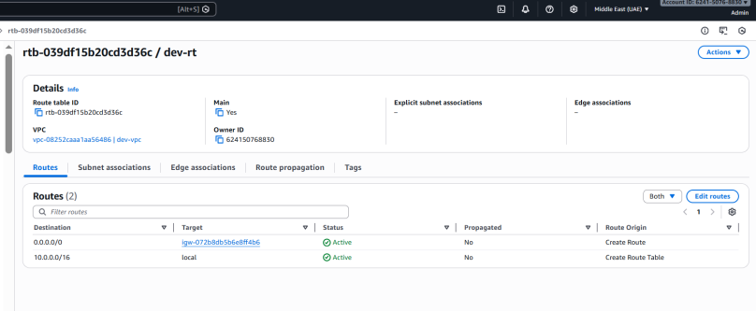

Task 9 — Security Group, Key Pair, EC2 Instance, user_data & nginx
- task9_my_ip_variable_added.png
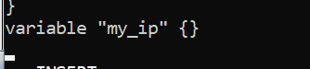
- task9_security_group_apply.png
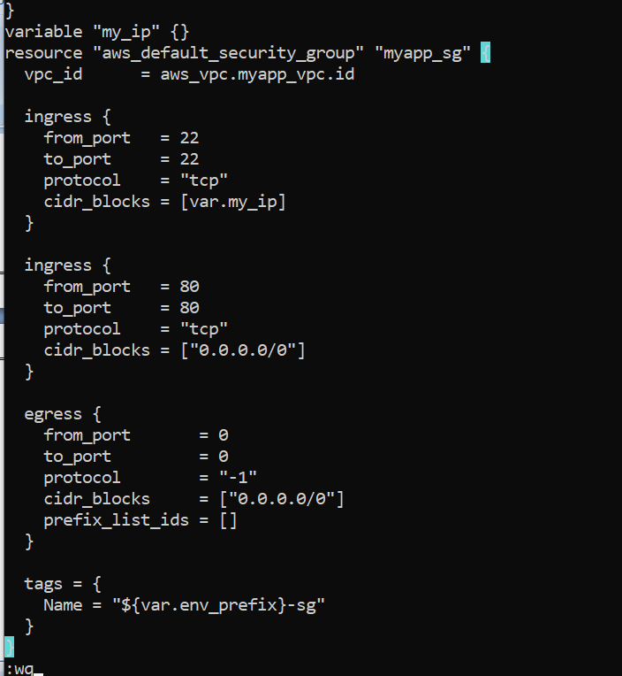
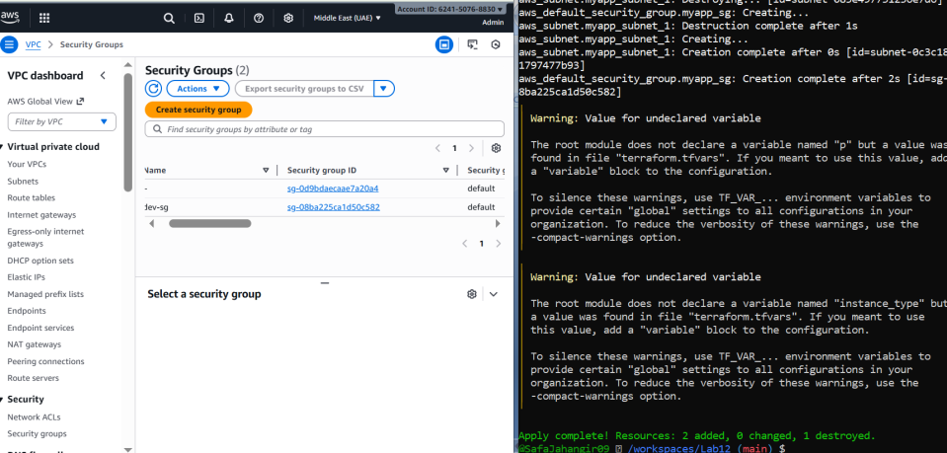
- task9_keypair_created_and_saved.png
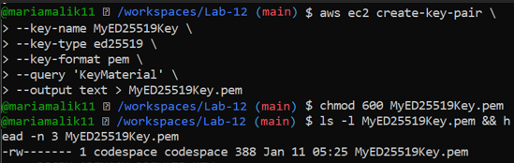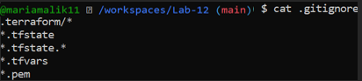

- task9_instance_type_set.png
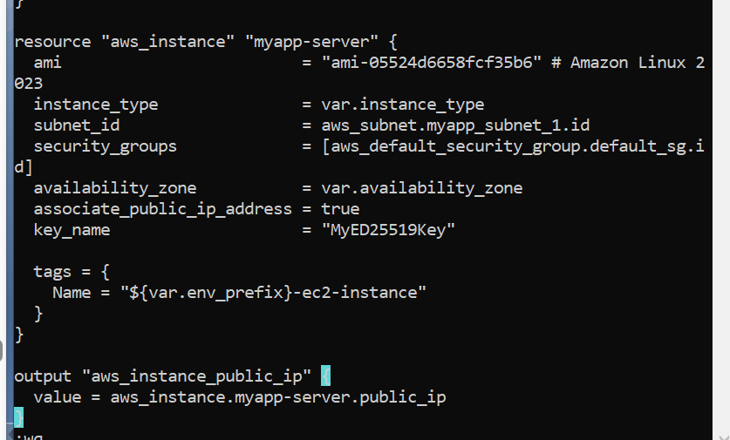
- task9_ec2_apply_and_public_ip.png
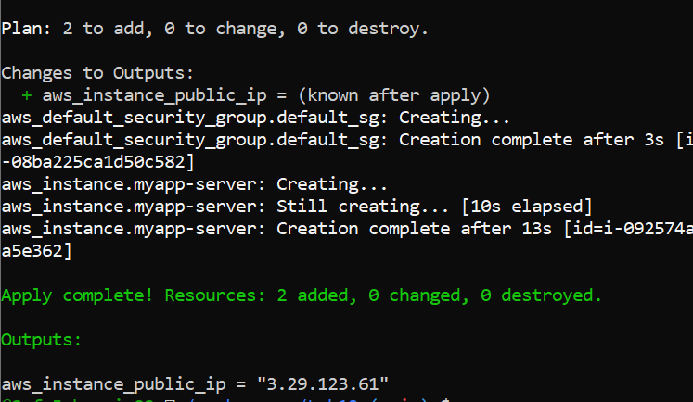
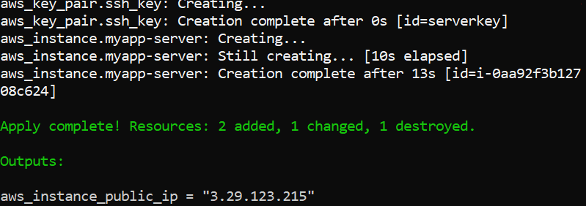
- task9_ssh_into_ec2.png
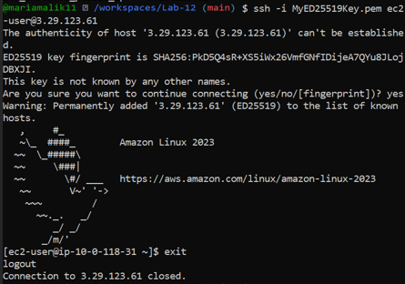
- task9_ssh_keypair_and_ssh.png
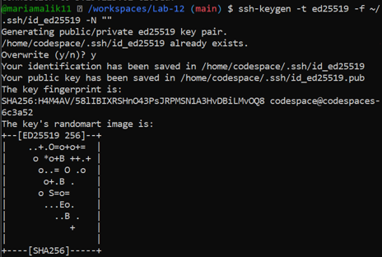
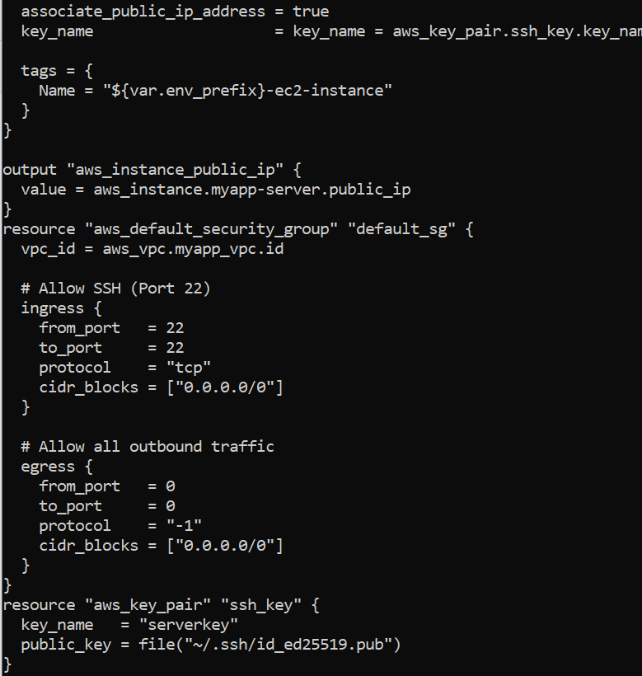

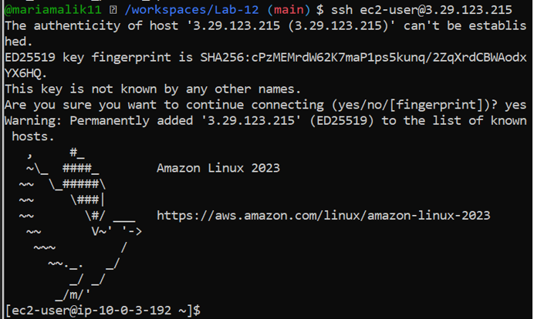
- task9_nginx_local_curl.png
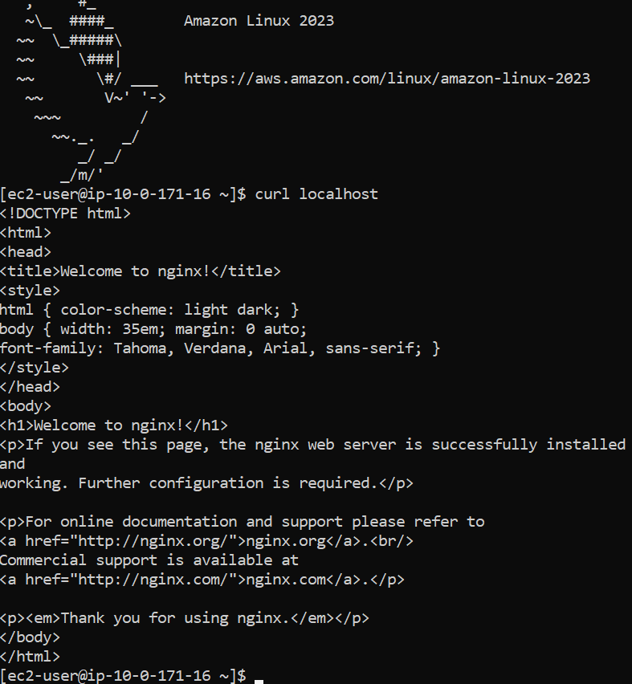
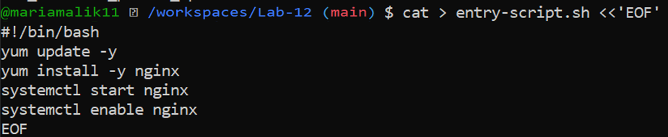
- task9_nginx_browser_page.png
